Facilitating Document Annotation Using Content And Querying Value

Data Flow Diagram:
User DFD:
Start

Registration

User Login

Request file and secret key
A

B

Is correct Secret Key?
Context search methods

No

Yes
User Downloads the file

End

Group Manager’s DFD:
Start

Views cloud data
A
Request from user
Generates Secret Key

B

Data Owner’s DFD:
Start
Manages Group Manager

Upload files to Cloud Server

END

Use Case Diagram:

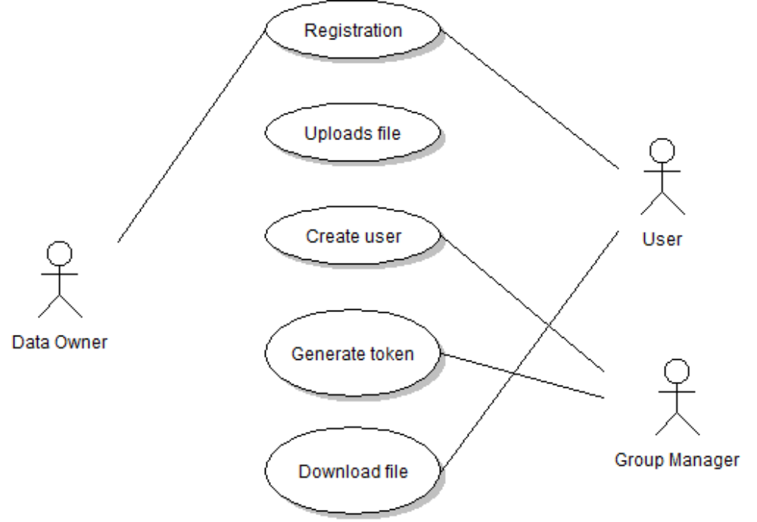

Class Diagrams
Userquery table
Fileid(primary key)
name
Path
Date
Secret key

GroupMgr table
Keyid(primary key)
Name
name(primary key)
Pass
EmailId
Date
ISBN
DataOwner table
Fileid(primary key)
Fileowner
Dataowner
Data
File

UserRegis table
Keyid(primary key)
Name
Username(primary key)
Pass
EmailId
Addr
City
Stat
Coun

Sequence Diagram:
